**Case Study – Structural Health Monitoring**

**Introduction:**

SHM is a vital tool to improve the safety and maintainability of critical structures such as bridges and buildings. SHM provides real time and accurate information about the structural health condition. It is a process of nondestructive evaluations to detect location and extent of damage, calculate the remaining life, and predict upcoming accident. SHM has become challenging task with the increase in development and construction of structures along with the

complexities involved in them. The demand for SHM has also increased due to increase in the necessity to ensure safety of the structures as well as the human lives associated with it. SHM is capable of detecting the damage early and make it feasible to take action before any loss occurs. The IoT brings new opportunities for our society. With the maturity of the IoT, one of the recent challenges in the structural engineering community is development of the IoT SHM systems that can provide a promising solution for rapid, accurate, and low-cost SHM systems. Moreover, the combination of SHM, cloud computing, and the IoT enabled ubiquitous services

and powerful processing of sensing data streams beyond the capability of traditional SHM system. Cloud platform allows the SHM data to be stored and used intelligently for smart monitoring and actuation with smart devices.

Here we are proposing a methodology to a complete SHM platform embedded with IoT is proposed to detect the size and location of damage in structures.

**Methodology:**

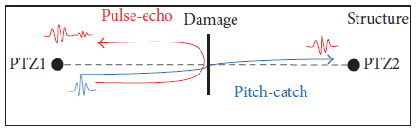

A combination of pulse-echo and pitch-catch techniques is proposed as shown in above figure. Pitch-catch technique is used to determine presence of damage. If any damage is found, the pulse-echo technique will be used to determine location of the damage. This method uses two PZT (Piezoelectric) sensors. The first transducer (PZT1) excites the signal towards the second transducer (PZT2) and picks up any waves that have been reflected back from damage that could not reach the second transducer, which uses the pulse-echo technique. The second, PTZ2, will receive wave feedback in a pitch catch manner. The proposed technique is good for any metal structure, for example, aluminum and steel. In order to detect if the structure is healthy or not, a cross correlation (CC) algorithm is used to check the similarity between excitation signal, E, at PTZ1 and received signal, R, at PTZ2.The CC value is used as a linear damage index and is defined as

$$CC = \frac{(1/N)\sum_{i=1}^{N}{(E_{i}-\overline{E})(R_{i}-\overline{R})}}{σ_{E}σ_{R}}$$

where 𝐸 and 𝑅 are the mean values of the two sets of signals and 𝜎𝐸 and 𝜎𝑅 are standard deviations of the signature signal sets 𝐸 and R, respectively. If the two signals are similar, CC=1, which mean that the structure is healthy; otherwise, the structure has damage. In order to determine the size and location of the damage, a mathematical model is proposed based on the dimensional diagram shown below.

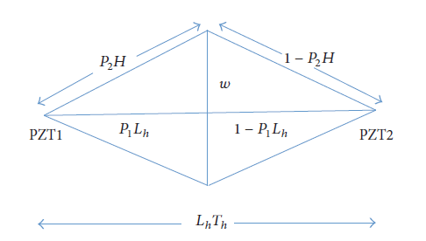

First, the speed of the wave must be calculated using a healthy model as in

$$\frac{L_{h}}{T_{h}}=W_{s}$$

where 𝐿ℎ is the length from exciter to sensor and 𝑇ℎ is the time between peak-peak. In order to find the damage location, 𝐿𝑐, we are using the following:

$$\frac{T_{c}}{2}W_{s}=L_{c}$$

where 𝑇𝑐 is the time it takes for a wave to travel to the damage and reflect back. After calculating the position, the next step would be determining the damage width. First, the

proportion of the damage position to the total length, 𝑃1, could be determined by

$$\frac{L_{c}}{L_{h}}=P_{1}$$

Due to the damage being present, the wave takes longer to travel from exciter to sensor, which implies that the wave travels a further distance. This distance, H, can be determined by

$$T_{t}W_{s}=H$$

where 𝑇𝑡 is the total time the wave takes to travel from exciter to the sensor with the presence of the damage. From these equations, a triangle can be made as seen in above figure. 𝐿𝑐 is the

base and 𝑃2𝐻is hypotenuse of this triangle. 𝑃1 and 𝑃2 are very close in value and only equal if 𝑃1 is 1/2. 𝑃2 can be determined using the following:

$$\frac{(H^{2}-L_{c}^{2}+2L_{c}^{2}P_{1})}{2H^{2}}=P_{2}$$

After 𝑃2 is calculated, the width of the damage is determined from the exciter/sensor axis using the Pythagorean Theorem:

$$\sqrt{{\left(P_{2}H\right)}^{2}-L_{c}^{2}}=W$$

These equations are used if the damage has the same width above and below the axis. If the damage is not symmetrical, the two waves might reach the sensor at slightly different times resulting in two 𝑇𝑡s, two 𝐻s, and two 𝑃2s to calculate the upper and lower part of the damage. From the above mathematical model, the damage location can be detected using (5) and the damage width can be determined using (7). One unique advantage of the proposed mathematical model is that it does not require high computational processing unit, allowing for implementation almost anywhere, anytime, and also easier integration with an IoT platform.

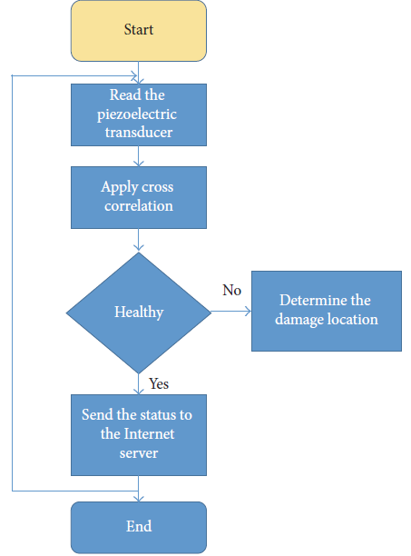

Above figure shows the flowchart of the proposed SHM technique.

**Proposed IoT Platform for SHM:**

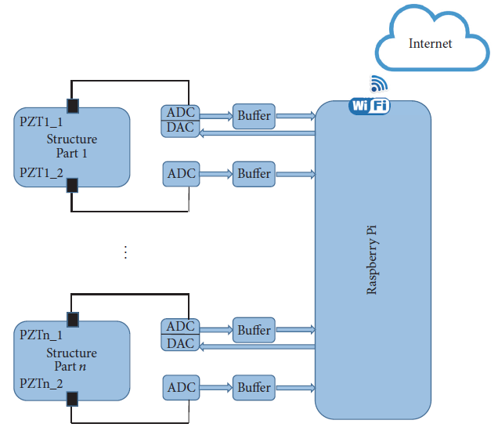

The proposed IoT platform consists of Wi-Fi module, Raspberry Pi, ADC, DAC, buffer, and PZT as shown in above figure. The two piezoelectric sensors are mounted on the structural and connected to a high-speed ADC. In the real case implementation, we will deploy the sensors in a way to catch all the possible damage. A buffer is used as a level conversion and to protect the Raspberry Pi. The Raspberry Pi generated the excitation signal and the DAC converted it to analog. In addition, the Raspberry Pi, using the proposed SHM technique, is used to detect if the structure has damage or not and the location of the damage if it is existing. Moreover, the Raspberry sends the structure health status to the Internet server. The data is stored on the Internet and can be monitored remotely from any mobile device. Moreover, the Internet server sends an alert if there is a damage in the structure.

**1. Wi-Fi Module:** Miniature Wi-Fi (802.11b/g/n) Module is a USB module that has 2.4GHz ISM band. It has a data rate up to 150Mbps (downlink) and up to 150Mbps (uplink). It uses IEEE 802.11n (draft), IEEE 802.11g, and IEEE 802.11b standards. The Wi-Fi module is used

to send the data to the cloud.

**2. Raspberry Pi 2:** The Raspberry Pi 2 is a single-board computer. It features a full Linux operating system with diverse programming and connectivity options. The onboard 900MHz quad-core ARM Cortex-A7 CPU allows for swift computation and analysis of data obtained from several nodes and transducers. The operating system of Raspberry Pi is Linux 3.18.5-v7+ and has 4 processors in one chip which is CPU ARMv7 Processor rev 5 (v7l). It has a RAM of 1 GB and maximum clock speed 900MHz.Normally, current drawn by Raspberry Pi 2 is 200mA. The Raspberry Pi will be used to collect the structure health and push it to the cloud using Wi- Fi module.

**3. ADC:** The CA3306 is a CMOS parallel ADC designed for applications demanding both low-power consumption and high-speed digitization. It is a 6-bit 15MSPS ADC with a parallel read out with single 5V supply. The power consumption is as low as 15mW, depending upon the operating clock frequency. It may be directly retrofitted into CA3300 sockets, offering improved linearity at a lower reference voltage and high operating speed with a 5V supply. The high conversion rate of this ADC is ideally suited for digitizing high speed signals in SHM application. If a higher resolution is needed, the overflow bit makes the connection of two or

more CA3306s in series possible to increase the resolution. Also, two CA3306smay be used to produce a 7-bit high speed converter that doubles the conversion speed, this will increase the sampling rate from 15MHz to 30MHz.

**4. DAC:** The MCP4725 is a low-power, high accuracy, single channel, 12-bit buffered voltage output DAC with nonvolatile memory (EEPROM). Its onboard precision output amplifier allows it to achieve rail-to-rail analog output swing. TheMCP4725 is an ideal DAC device where design simplicity and small footprint are desired and for applications requiring the DAC device settings to be saved during power-off time.

**5. Buffer:** The 74HC4050 is a hex buffer with overvoltage tolerant inputs. Inputs are overvoltage tolerant up to 15V which enables the device to be used in high-to-low level shifting applications.

**6. Piezoelectric Sensors:** The PZT transducer converts mechanical energy to electric signals or vice versa. They can work as an actuator to excite an elastic lamb wave based on the electrical signal applied to the PZT crystal. It can also be used as a transducer to transform the responding elastic lamb waves into an electrical signal. Two PTZs sensors are mounted on structure: PZT1 (excitation) will send the excitation signal and PZT2 (receiver) will receive the signal. The CA3306 is operating at 5V, which means that we cannot connect it directly to the Raspberry Pi which operates at 3.3V. Accordingly, a level converter in between is needed.

The simplest way to do level conversion is to use a buffer such as CMOS 74HC4050. As the buffer runs at 3.3V, so it is necessary to place a pull-up resistor to 5V behind the clock buffer.

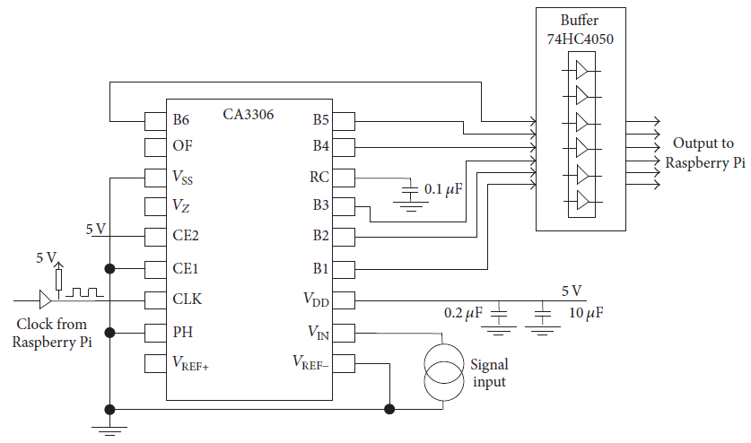

Above figure shows the circuit diagram of both the ADC and the buffer.

**Test and Evaluation:**

In order to evaluate the proposed platform, a healthy aluminum sheet and another sheet with damage were used. The unhealthy sheet has damage that is 30 cm far from the exciter piezoelectric sensor and 7 cm width as shown below.

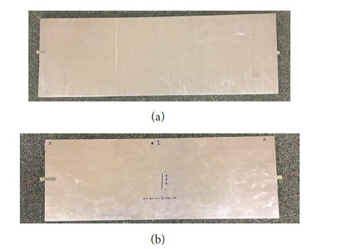

Healthy Aluminum Sheet



Aluminum Sheet with Damage

The proposed platform is used to check both sheets and send the data to the Internet server. These two sheets are tested separately by the proposed platform.

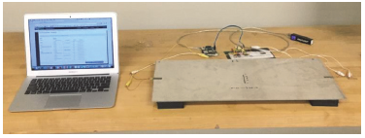

Above figure shows the test bed as located in the lab. The health status was sent to the Internet server that hosted on ThingWorx. ThingWorx is a technology platform designed for the of applications for smart, connected products by giving developers the tools they need to connect, build, analyze, experience, and collaborate about their “things”.

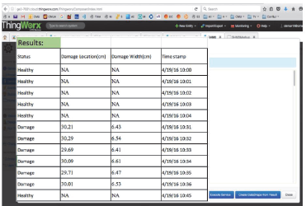

Above figure shows the results on ThingWorx.

|  |  |  |  |  |
| --- | --- | --- | --- | --- |
| **Results on the Internet** | | | | |
| Actual Status | Damage Location (cm) | Damage Width (cm) | % error of the damage location | % error of the damage width |
| Healthy | NA | NA | NA | NA |
| Healthy | NA | NA | NA | NA |
| Healthy | NA | NA | NA | NA |
| Healthy | NA | NA | NA | NA |
| Healthy | NA | NA | NA | NA |
| Damage | 30.21 | 6.43 | 0.7% | 8.14% |
| Damage | 30.29 | 6.54 | 0.97% | 6.57% |
| Damage | 29.69 | 6.41 | 1.03% | 8.43% |
| Damage | 30.09 | 6.61 | 0.3% | 5.57% |
| Damage | 29.71 | 6.47 | 0.97% | 7.57% |
| Damage | 30.01 | 6.53 | 0.03% | 6.71% |
| Healthy | NA | NA | NA | NA |
| Healthy | NA | NA | NA | NA |

Above shows the percentage error of both the damage location and damage width between the actual sheet’s status and the data on the Internet. Results show that the proposed IoT SHM platform successfully checked if the sheet is healthy or not with 0% error. In addition, the proposed platform has a maximum of 1.03% error for the damage location and a maximum of 8.43%error for the damage width.

**Conclusion:**

Here, a complete real-time IoT platform for SHM was proposed. It consists of a Wi-Fi module, Raspberry Pi, DAC, ADC, buffer, and PZTs. The two PZTs are mounted on the structure and connected to a high-speed ADC. A buffer was used as a level conversion and to protect the Raspberry Pi. The Raspberry Pi generates the excitation signal and the DAC converts it to analog. In addition, the Raspberry Pi was used to detect if the structure has damage or not. Moreover, the Raspberry was used to send the structure health status to the Internet server. The data was stored on the Internet server and can be monitored remotely from any mobile device. The system has been validated using a real test bed in the lab. Results show that the proposed IoT SHM platform successfully checked if the sheet is healthy or not with 0% error.